 | SIMATS ENGINEERING  Department of Computer Science and Engineering  CSA15 Cloud Computing and Big Data Analytics  CO2 AT3 - Capstone Cloud Infrastructure Case Analysis and Defense  Editable student template for application-based cloud virtualization and SDDC/cloud operations defense
Assessment Metadata
Course Code | CSA15
Course Title | Cloud Computing and Big Data Analytics
Assessment | CO2 AT3 - Capstone Cloud Infrastructure Case Analysis and Defense
Submission Type | Individual digital case analysis and infrastructure defense based on the same capstone title used in CO1, CO2 AT1 and CO2 AT2
Faculty | Dr C. Rajesh Babu
Employee ID | SSETSCS415
Submission Mode | Completed DOCX template and GitHub repository link through Google Classroom
How This Template Works
- Use the same capstone title used in CO1, CO2 AT1 and CO2 AT2.
- Do not recalculate all VM sizing or repeat all configuration screenshots. Summarize the final AT1/AT2 evidence and use it for design defense.
- Answer all five questions with application-oriented reasoning connected to the capstone product.
- Include sustainable cloud operation decisions wherever relevant: right-sized resources, log retention, storage lifecycle, scheduled shutdown, API-call reduction and VM/container/serverless comparison.
- Paste the final topology diagram in the given response area. The sample diagram is only a structure; redraw it for the student's own product.
- Upload this completed document and supporting evidence to GitHub, then submit the repository link through Google Classroom.
Assessment Focus
AT1 answered what VM is required. AT2 showed configuration or simulation evidence. AT3 asks whether the student can defend the complete infrastructure design under application, security, operations and failure conditions.
Student and Capstone Details
Student Name | P Rahul sai
Register Number | 192524226
Class / Slot | Slot B
Capstone Title | BloodBridge: Emergency Blood Donor Matching Application
CO1 Evidence Link
CO2 AT1 VM Recommendation | vCPU: ___4_ RAM: __8__ GB Storage: _64___ GB VM Class: __Medium__
CO2 AT2 Evidence Link
GitHub Repository Link
Submission Date
Evidence Carry-Forward Summary
Evidence Source | Student Entry | How It Supports AT3 Defense
CO1 concept map / presentation | BloodBridge concept and architecture | Defines project objectives and cloud requirements.
CO2 AT1 sizing workbook | VM sizing (4 vCPU, 8 GB RAM, 64 GB SSD) | Supports infrastructure sizing decisions.
VM calibration sheet | CPU, RAM and storage calculations | Justifies selected VM configuration.
CO2 AT2 practical evidence | VM setup, security and Docker evidence | Demonstrates practical deployment skills.
Capstone architecture decision | Multi-tier cloud architecture | Supports scalability and modular deployment.
Q1: Virtualization Value and Capstone Cloud Deployment Summary
Explain your capstone product, expected workload, cloud need and deployment context. Analyze how virtualization improves cost efficiency, resource utilization, workload isolation, infrastructure flexibility and cloud deployment readiness for your product.
Design Point | Student Response
Capstone product and users | Emergency blood donor matching system for donors, hospitals and patients.
Expected workload | Moderate traffic with emergency request spikes.
Cloud need | High availability, database storage and secure access.
Virtualization value | Efficient resource allocation and isolated environments.
Cost and utilization benefit | Shared infrastructure reduces hardware and operational costs.
Isolation and flexibility benefit | Independent services improve maintenance and scalability.
Case Analysis Response: Write 8-12 technical lines connecting virtualization value to your capstone product.
BloodBridge is a cloud-based application that connects blood donors, hospitals, and patients during emergencies. Virtualization enables multiple services to run securely on the same physical infrastructure while remaining isolated. The selected virtual machine configuration supports the backend API, authentication, and database requirements efficiently. Resources such as CPU, memory, and storage can be allocated according to workload demands. Virtualization also simplifies backup, migration, and recovery using snapshots and cloned environments. Cloud deployment improves application availability and allows future scaling when the number of users increases. Infrastructure management becomes easier because virtual machines can be updated independently without affecting other services. Overall, virtualization provides a reliable, cost-effective, and flexible foundation for the BloodBridge application.

Q2: Rapid Provisioning, Testing and Virtual Machine Lifecycle Case
Using your CO2 AT1 VM recommendation and CO2 AT2 practical evidence, explain how virtual machines, VM images, templates, snapshots, clones or containers support rapid provisioning, testing, deployment, rollback and maintenance for your capstone product.
Lifecycle Element | AT1/AT2 Evidence Used | Capstone Use / Justification
VM image or base environment | Ubuntu Server 22.04 LTS | Stable environment for BloodBridge deployment.
Template or repeatable setup | VM template | Quick deployment of identical environments.
Snapshot / rollback | Snapshot before updates | Restore the system after failures.
Clone / testing copy | Full VM clone | Safe testing without affecting production.
Container or VM decision | VM + Docker containers | Better isolation and modular deployment.
Maintenance and update plan | Scheduled updates and backups | Keeps the system secure and reliable.
Case Analysis Response: Explain how lifecycle practices reduce deployment delay and risk.
Virtual machine lifecycle management reduces deployment time and operational risk. A standard VM image provides a consistent deployment environment, while templates allow rapid provisioning of new instances. Snapshots enable quick rollback after configuration errors or failed updates. Cloning creates isolated testing environments without affecting production services. Docker containers improve portability and simplify application deployment. Regular maintenance, backups, and software updates ensure reliability, security, and continuous availability of the BloodBridge application.

Q3: Final Cloud Deployment Topology and SOA/API Service Integration Case
Draw and explain the final deployment topology for your capstone product. Show frontend, backend/API, database, storage, authentication, notification, analytics and any VM/container/managed cloud service components. Explain how SOA/API-based integration connects these modules and supports modular cloud service design.
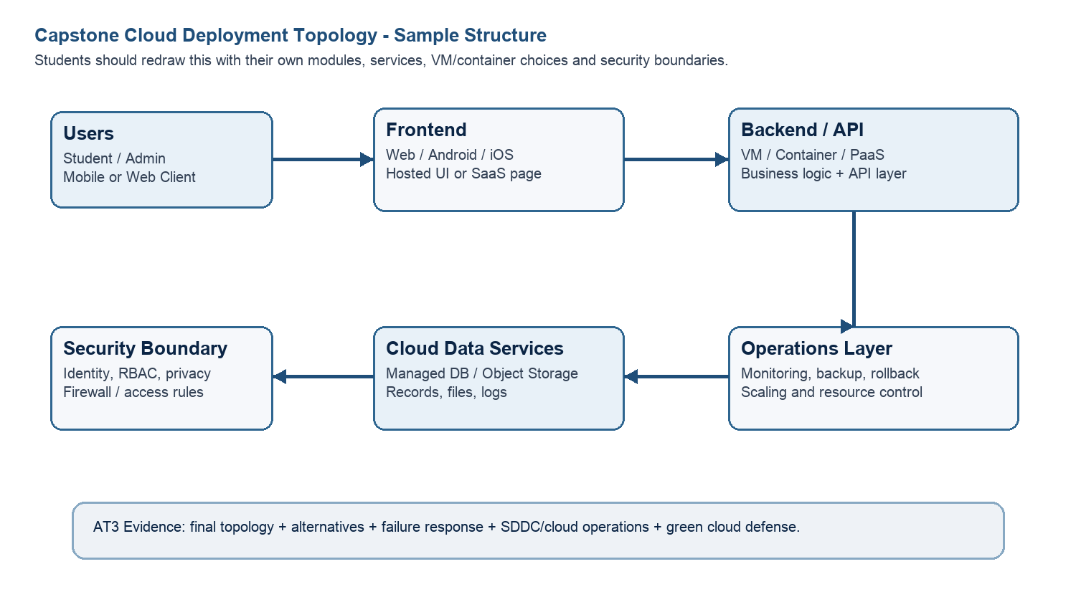
Architecture Component | Technology / Service | VM / Container / Managed Service / SaaS | Integration Method
Frontend | React / HTML, CSS, JavaScript | Container | REST API
Backend/API | Python Flask | VM + Container | REST API
Database | Firebase Firestore | Managed Service | Firebase SDK/API
Storage | Firebase Storage | Managed Service | Cloud Storage API
Authentication | Firebase Authentication | Managed Service | OAuth / Firebase Auth
Notification | Firebase Cloud Messaging | Managed Service | Push Notification API
Analytics / AI Module | Python Analytics | Container | REST API
Paste or draw the final capstone deployment topology diagram here.
Users
│
▼
Frontend (React Website)
│
REST API Calls
│
▼
Backend (Python Flask API)
┌───────────┼────────────┐
▼ ▼ ▼
Firebase DB Firebase Firebase
Firestore Auth Storage
│
▼
Notification Service (FCM)
│
▼
Analytics / Reports

SOA/API Integration Explanation: Explain how services communicate and why modular service design is useful.
The BloodBridge application follows a Service-Oriented Architecture where each module performs a specific function and communicates using REST APIs. The frontend sends requests to the backend API, which processes donor searches, authentication, and emergency requests. The backend interacts with Firebase Firestore for data storage, Firebase Authentication for secure user login, and Firebase Storage for documents and images. Notification services send emergency alerts to nearby donors. This modular architecture improves scalability, maintainability, security, and allows each service to be updated independently without affecting the entire application.

Q4: Design Alternatives, Identity, Access and Federated Cloud Privacy Case
Compare at least two deployment alternatives for your capstone product, such as single VM, multi-tier VM, containerized deployment, managed backend, federated cloud or hybrid cloud model. Justify the selected design by analyzing identity management, role-based access control, federated access, data sharing, privacy protection and security risks.
Deployment Alternative | Advantages | Limitations / Risks | Identity and Privacy Impact
Alternative 1 – Single VM | Easy to deploy and low cost | Limited scalability | Basic authentication and access control
Alternative 2 – Containerized Deployment | Scalable, portable and efficient | Requires container management | Better isolation and secure service communication
Selected Design – Multi-tier Cloud with Managed Services | High availability, scalability and security | Slightly higher configuration complexity | Strong RBAC, secure authentication and better privacy protection
Deployment Alternative | Advantages | Limitations / Risks | Identity and Privacy Impact
Alternative 1 – Single VM | Easy to deploy and low cost | Limited scalability | Basic authentication and access control
Alternative 2 – Containerized Deployment | Scalable, portable and efficient | Requires container management | Better isolation and secure service communication
Selected Design – Multi-tier Cloud with Managed Services | High availability, scalability and security | Slightly higher configuration complexity | Strong RBAC, secure authentication and better privacy protection
Security Area |  | Student Decision
User roles |  | Admin, Donor, Hospital, Patient
Authentication method |  | Firebase Authentication with Email/OTP
Role-based access control |  | Different permissions for each user role
Federated access / partner access |  | Hospitals and blood banks access through secure APIs
Sensitive data handled |  | Personal details, blood group, contact information, location
Privacy protection decision |  | Encrypt data, HTTPS communication and authenticated access
Case Analysis Response: Defend why the selected design is better for identity, access and privacy.
The selected multi-tier cloud architecture provides better security, scalability, and privacy than a single VM deployment. Firebase Authentication ensures secure user identity management, while role-based access control restricts access based on user responsibilities. Sensitive donor and patient information is protected using encrypted communication and authenticated API requests. Managed cloud services reduce maintenance effort and improve reliability. This architecture also supports future integration with hospitals and blood banks through secure APIs while maintaining user privacy and regulatory compliance.

Q5: Software-Defined Datacenter and Cloud Operations Defense Case
Analyze how your infrastructure will respond to operational and failure scenarios such as VM failure, database growth, traffic spike, credential leakage, service outage, resource contention or cost increase. Explain how SDDC concepts and cloud operations practices such as automated provisioning, software-defined networking, software-defined storage, monitoring, logging, backup, rollback, scaling, resource control and maintenance improve the final infrastructure design. Include Green Computing decisions such as resource right-sizing, storage lifecycle control, log retention, API-call reduction, scheduled shutdown, VM/container/serverless comparison and carbon/energy proxy indicators where relevant.
Operational / Failure Scenario | Expected Impact | SDDC / Cloud Operations Response | Evidence or Control
VM failure | Application unavailable | Restore VM or migrate workload | Backup & Snapshot
Database growth | Slower queries | Scale database and optimize indexing | Managed Firestore
Traffic spike | High CPU usage | Auto-scale backend resources | Load balancing
Credential leakage | Unauthorized access | Reset credentials and enable MFA | Firebase Authentication
Service outage | Temporary downtime | Failover and backup services | Monitoring & Alerts
Resource contention | Reduced performance | Allocate additional CPU/RAM | Resource monitoring
Cost increase | Higher cloud bill | Right-size VM and optimize usage | Cost monitoring
Operational Readiness Area |  | Student Plan
Automated provisioning |  | Use VM templates and deployment scripts.
Software-defined networking |  | Secure virtual network with firewall rules.
Software-defined storage |  | Use managed cloud storage with backups.
Monitoring and logging |  | Enable logs and performance monitoring.
Backup and rollback |  | Regular backups and VM snapshots.
Scaling and elasticity |  | Scale resources based on workload.
Resource control and maintenance |  | Periodic updates and health checks.
Green Computing and sustainability control |  | Right-size resources and shut down idle services.
Green Cloud Decision |  | Student Justification
VM vs Container vs Serverless choice |  | Containers are preferred for backend services due to lower resource usage, while managed cloud services handle authentication and storage efficiently.
Scheduled shutdown / idle-resource control |  | Development VMs will be stopped when not in use to reduce cloud costs and energy consumption.
Log and file retention policy |  | Logs will be retained for 30 days, and unnecessary files will be deleted periodically.
Storage lifecycle and backup cleanup |  | Old backups and unused files will be archived or removed automatically.
API-call or polling reduction |  | API requests will be optimized using caching and efficient database queries to reduce unnecessary traffic.
Carbon/energy proxy indicator to track |  | Monitor VM uptime, CPU utilization, storage usage, and energy-efficient resource utilization.
Green Cloud Decision |  | Student Justification
Final Infrastructure Defense Statement: State whether the design is ready for prototype, pilot or production. Defend reliability, security, SDDC/cloud operations and Green Computing improvements required next.
The BloodBridge infrastructure is ready for prototype deployment. The selected multi-tier cloud architecture provides secure authentication, scalable backend services, managed cloud storage, and reliable database support. Virtualization and containerization improve deployment flexibility, while monitoring, backups, snapshots, and automated scaling increase system reliability. Green computing practices such as right-sizing resources, scheduled shutdowns, storage lifecycle management, and API optimization reduce operational costs and energy consumption. Before production deployment, additional security hardening, load balancing, disaster recovery, and continuous monitoring will further improve availability and performance.

CO2 Reflection and Individual Defense
This section must be individually written. It should show what the student understands from the complete CO2 chain: infrastructure sizing, practical configuration evidence and final operations defense.
Reflection Prompt | Student Response
What is the strongest infrastructure decision in your capstone design? | Choosing a multi-tier cloud architecture with managed services for better scalability and security.
Which CO2 concept became clearer after AT1, AT2 and AT3? | VM sizing, virtualization, cloud deployment, and infrastructure management.
Which risk is most serious for your capstone: failure, cost, privacy, scaling or sustainability? | Privacy and security of donor and patient data are the most critical risks.
What evidence would you show during viva to defend your infrastructure design? | VM sizing calculations, deployment topology, practical VM/Docker evidence, GitHub repository, and cloud architecture diagrams.
What will you improve before final capstone deployment? | Add load balancing, disaster recovery, enhanced monitoring, stronger security policies, and performance optimization.

Student-Facing Assessment Criteria
Criteria | Descriptor
Capstone continuity | The answer uses the same capstone title and connects CO1, CO2 AT1 and CO2 AT2 evidence.
Virtualization and lifecycle reasoning | VM, image, snapshot, clone, container or managed-service decisions are technically justified.
Topology and integration clarity | Architecture diagram and SOA/API explanation show clear module interaction.
Identity, access and privacy | Roles, authentication, RBAC, federated access, sensitive data and privacy decisions are defended.
SDDC/cloud operations | Failure response, monitoring, logging, scaling, backup, rollback and resource control are addressed.
Green Computing defense | Right-sizing, retention, API efficiency, idle-resource control and sustainable cloud choices are explained.
Submission quality | GitHub, template completion, evidence references and individual reflection are complete.
GitHub and Google Classroom Submission
Repository Item | Expected Content
README.md | Capstone title, student details, final VM recommendation, deployment topology summary and AT3 evidence index.
Completed AT3 document | This completed editable DOCX or exported PDF if instructed.
Diagram image | Final topology diagram if created separately.
Evidence references | Links or screenshots from CO1, CO2 AT1 and CO2 AT2 as needed.
Green Computing note | Short README section explaining sustainable cloud choices and resource-control decisions.
Google Classroom | Submit the GitHub repository link through GCR.
Student Assurance
I confirm that this case analysis, design reasoning, topology diagram and final defense statement were prepared individually by me for the stated capstone title. I have not uploaded passwords, tokens, private keys or sensitive account information.
Student Name | P Rahul Sai
Register Number | 192524226
Signature | P Rahul Sai
Date | 29/07/2026

Faculty Verification
Faculty Name | Dr C. Rajesh Babu
Employee ID | SSETSCS415
Constructive Feedback / Remarks
Strength Observed
Improvement Suggested
Signature / Date

